ORDINANCE NO. 2026-22

An Ordinance of Ivins City, Utah,
Amending the Ivins City Code to Clarify Regulations Governing Accessory Dwelling Units, Garages, Carports, Accessory Units for Agriculture, and Manufactured Dwelling Units
WHEREAS the city council for Ivins City (the “City Council”) is authorized by law to exercise its legislative powers through ordinances as are necessary for carrying into effect the duties and powers of the City Council and as are necessary and proper to provide for the safety and preserve the health, and promote the prosperity, improve the morals, peace and good order, comfort, and convenience of Ivins City and its inhabitants, and for the protection of property in Ivins City (see Utah Code § 10-8-84; Ivins City Code §§ 2.01.301, et seq.)
WHEREAS before the City Council can pass an ordinance regulating land use the planning commission for Ivins City (the “Planning Commission”) must consider the regulation and conduct a public meeting regarding the proposed land use regulation;
WHEREAS after conducting a public hearing regarding this ordinance on October 13, 2026, the Planning Commission recommended that the City Council approve this ordinance;
WHEREAS the City Council has investigated and considered clarifying regulations governing accessory dwelling units, garages, carports, accessory units for agriculture, and manufactured homes.
WHEREAS the City Council has considered the impact this ordinance may have on family health, stability and formation;
WHEREAS the City Council finds clarifying the regulations governing accessory dwelling units, garages, carports, accessory units for agriculture and manufactured homes will be in the best interests of the welfare of the citizens of Ivins.
NOW, THEREFORE, BE IT ORDAINED by the City Council of Ivins City as follows:
Section 1. Amendment to Sections 16.12.103 and 104 of the Ivins City Code. Sections 16.12.103 and 104 of the Ivins City Code is hereby amended in its entirety as follows:
See Exhibit A
Section 2. Amendment to Section 16.34.102 of the Ivins City Code. The definition of “Dwelling Unit, Manufactured” found in section 16.34.102 of the Ivins City Code is hereby amended in its entirety as follows:
See Exhibit B
Section 3. Severability. If any section, clause, or portion of this ordinance is declared invalid by a court of competent jurisdiction, the remainder shall not be affected thereby and shall remain in full force and effect.
Section 4. Effective Date. This Ordinance shall become effective immediately upon passage and publication.
PASSED AND ADOPTED BY THE IVINS CITY COUNCIL, STATE OF UTAH, ON THIS ____ DAY OF _______________, 2026, BY THE FOLLOWING VOTE:
 | AYE | NAY | ABSTAIN | ABSENT
Mike Scott | _____ | _____ | _____ | _____
Sharon Barton | _____ | _____ | _____ | _____
Sharon Gillespie | _____ | _____ | _____ | _____
Dillon Hurt | _____ | _____ | _____ | _____
Wayne Pennington | _____ | _____ | _____ | _____
Kevin Smith, Mayor
ATTEST:
Kari D. Jimenez, City Recorder

Exhibit A

16.12.103: ACCESSORY DWELLING UNITS, ACCESSORY GARAGES AND CARPORTS AND ACCESSORY UNITS FOR AGRICULTURE:
(1) The purpose of allowing accessory dwelling units (ADUs) is to provide additional long-term housing in the community. This can also provide supplementary income opportunities for property owners. ADUs are an important tool for the housing goals of the City and allow for alternative and flexible housing options for owner-occupied single-family residences. Ivins City will regulate ADUs through its city code to minimize the impact on neighboring properties and to promote the health, safety and welfare of all residents. The standards identified in this section 16.12.103 are created to:
(a) Create new housing units while respecting the appearance, neighborhood character, and scale of single-family residential developments.
(b) Provide more housing choices in residential zones throughout the city.
(c) Allow more efficient use of existing housing and large yards.
(d) Provide housing options for family caregivers, adult children, aging parents, and families seeking smaller housing.
(e) Offer a means for residents, particularly seniors, single parents, and families with grown children, to remain in their homes and neighborhoods, and obtain extra income, security, companionship, and services.
(f) Broaden the range of affordable housing options throughout the city.
(2) Definitions:
ACCESSORY DWELLING UNIT: A dwelling unit that is located on a single-family residential lot in addition to the primary dwelling unit. No accessory dwelling unit may be allowed in any multi-family dwelling or multi-family lot. No accessory dwelling unit may be allowed within any zone on any lot that cannot satisfy the parking, setbacks, or lot coverage requirements listed herein. A maximum of one accessory dwelling unit shall be allowed in each owner-occupied single-family dwelling, or in a detached accessory structure associated with a single-family dwelling.

CARPORT: A roofed structure, either attached or detached and open on at least three sides, used for the parking of motor vehicles. Detached carports shall be open on four (4) sides. The floor surface of attached and detached carports can be concrete, gravel, or asphalt. There can be no enclosed use above a carport.
EXTERNAL ACCESSORY DWELLING UNIT (ADUE): A self-contained dwelling unit located on an owner-occupied property that is in a detached building providing complete independent living facilities for one or more persons, including permanent provisions for living, sleeping, eating, cooking and sanitation, including a separate kitchen. ADUEs are intended to provide long-term housing and shall not be used as vacation rentals, short-term rentals, or transient lodging.
GARAGE: A fully enclosed structure, either attached or detached, used for the parking and storage of motor vehicles.
INTERNAL ACCESSORY DWELLING UNIT (ADUI): An accessory dwelling unit within the footprint or attached to a single-family residential building providing complete independent living facilities for one or more persons, including permanent provisions for living, sleeping, eating, cooking and sanitation including a separate kitchen and complies with Chapter 11 of this Code and Utah State Law 10-21-303. ADUIs are intended to provide long-term housing and shall not be used as vacation rentals, short term rentals, or transient lodging.
OWNER-OCCUPIED: No ADUI or ADUE shall be created, established or occupied in a single-family dwelling unless the owner of the property occupies either a portion of the main dwelling or a ADUE on the same single-family lot. For this section, the term "Owner-Occupied" shall be defined as full-time residency within the home by the bona fide property owner(s) as shown on the County Tax assessment website.
SQUARE FEET: For the purpose of measuring the size of a structure, "square feet" means the gross building area (GBA) which is the total floor area of a building, measured from the exterior face of exterior walls. It does not include exterior spaces such as porches, decks, patios, carports, or attached garages.
(3) General Regulations:
(a) Except as provided in this Code, no ADUE or ADUI shall be erected, raised, moved, placed, reconstructed, extended, enlarged or altered except in conformity with Ivins City regulations.
(b) All ADUEs and ADUIs hereafter erected in Ivins City shall comply with the current standards, codes, and ordinances adopted by Ivins City.
(c) ADUEs and ADUIs may be authorized on all lots located only in medium-density and low-density single-family residential zones, provided all requirements of this title, all other land use ordinances and the Building Code are met.
(4) Development Standards:
(a) The property owner, which shall include the titleholder, must occupy either the primary dwelling unit, the ADUE, or the ADUI as their permanent residence. Applications for an ADUE or ADUI will require evidence of owner occupancy.
(b) ADUEs or ADUIs shall not be sold separately from the primary housing unit.
(c) A maximum of one (1) ADUE may be established on each individual, separate legal lot, such that the lot meets all requirements, including minimum lot size, for the zoning district in which the lot is located. A property can also have one ADUI.
(d) The design and size of the ADUE or ADUI shall conform to all applicable standards in the building, plumbing, electrical, mechanical, fire, health and other applicable codes.
(e) Installing separate utility meters and separate addresses for the ADUE or ADUI is prohibited. Addresses are described in subsection 11.
(f) The square footage of an ADUE shall not exceed one thousand (1,000) square feet. The minimum square footage is four hundred (400) square feet. Either will be required to meet the lot coverage requirements. The ADUE square footage shall cover no more than thirty percent (30%) of the rear yard area.
(g) The occupants of the ADUE or ADUI shall not sublease any portion of the ADUE or ADUI to other individuals.
(h) ADUEs and ADUIs and the main dwelling must be on the same parcel and may not be subdivided.
(i) ADUEs and ADUIs shall be constructed of materials and colors designed to blend with the primary building and meet Chapter 19 Design Requirements of the Ivins City Code, except to the extent the design requirement are prohibited by Section 10-20-618 of the Utah Code.
(j) A minimum of one (1) off-street parking space must be provided for the ADUEs or ADUIs. ADUEs or ADUIs greater than six hundred fifty (650) square feet shall provide two (2) off-street parking spaces.
(k) The construction of all ADUEs and ADUIs shall meet all the requirements of the adopted City Building Code.
(l) An ADUE shall be located as a permanent structure on the lot. No manufactured dwelling unit not affixed to the property in a manner authorized by the building code, travel trailers, boats, recreational vehicles, cargo containers, shipping crates, boxes, campers, tents, or other temporary structures/vehicles shall be used as an ADUE or any other type of accessory building.
(m) The lot proposed for an ADUE shall have an existing family dwelling unit established or approved prior to the consideration of the use applications to allow the ADUE.
(n) No stormwater runoff from any accessory building shall be allowed to run onto adjacent property.
(o) Accessory buildings, located on corner lots, shall meet the required corner side yard setback applicable in the zoning district in which the accessory building is located.
(p) The ADUE or ADUI shall not be sold or conveyed and shall only be allowed for long-term rental.
(q) Occupancy: ADUEs and ADUIs shall only be provided for the occupancy of one family. Definition of Family is provided in section 16.34.102 Definitions of General Purpose.
(5) Garages: See also section 16.12.104 of this chapter for garage requirements.
(a) An accessory garage may be attached to or detached from the primary building.
(b) All garages and other accessory buildings located within ten feet (10') of the primary building shall be considered attached and part of the primary building and the setback requirements applicable to the primary building shall apply.
(c) An accessory garage that is detached from a primary building shall meet all requirements for the location of a detached accessory building, as provided herein.
(d) Accessory carports are allowed.
(e) Height: Detached carports shall be as per Table 16-1.
(f) No detached garage shall be greater in height than Table 16-1.
(g) No detached garage or other accessory buildings shall be located in any required front yard.
(h) Metal carports are only approved in areas outlined in figure 12-2.
Figure 12-2
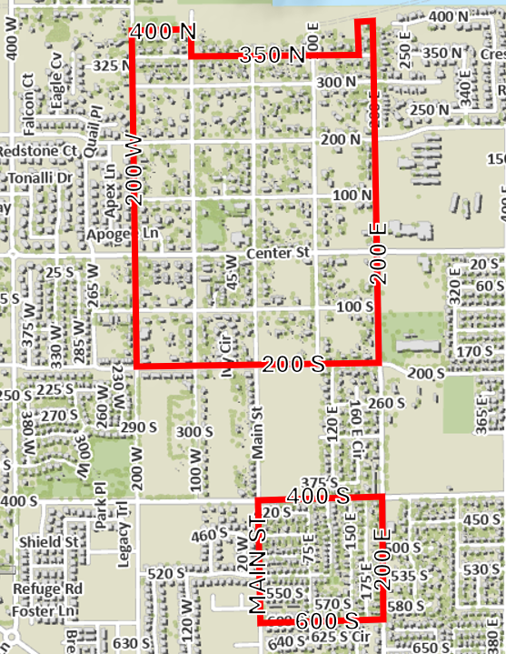

(i) No ADUEs or ADUIs will be allowed on top of detached garages.
(6) Carports:
(a) Maximum Size: Twelve feet (12') in width by fifty feet (50') in length or calculated by the following formulas:
(i) The total square footage of any attached carport shall not be greater than fifty percent (50%) of the square footage of the footprint of the primary structure excluding the attached garage on lots less than one-half (1/2) acre, sixty percent (60%) on lots one-half (1/2) but less than one acre and seventy percent (70%) on lots one acre or larger.
(ii) The total square footage of any detached carport shall not be greater than fifty percent (50%) of the square footage of the footprint of the primary structure including the attached garage on lots less than one-half (1/2) acre, sixty percent (60%) on lots one-half (1/2) acre to less than one acre, and seventy percent (70%) on lots one acre or larger.
(b) Maximum Entry Height: Thirteen feet, six inches (13'6").
(c) Materials: Carports may be constructed of materials to match the architectural style of the existing residence or shall be an engineered metal building. Poles supporting a metal carport shall be of a color compatible with the exterior of the primary structure.
(d) Minimum Setbacks: Comply with the minimum setback requirements for the zoning district in which it is located.
(e) Front Of Carport: The front of the carport shall be located at least three feet (3') back from the front of the structure on the side that it is located on.
(f) Conformance With Building Code: Engineered to resist wind and seismic loads in conformance with the most recently adopted edition of the Building and/or Residential Code.
(g) Number Allowed: No more than one carport shall be permitted for each dwelling unit.
(h) Materials Prohibited: Carports constructed of corrugated metal, fiberglass panels, and fabric materials are expressly prohibited.
(i) Height: Carports may be up to the height of the primary residence or up to fifteen feet (15') tall, whichever is lower. The carport may have a flat roof.
(7) Accessory Units for Agriculture:
(a) Accessory buildings, except for agricultural use accessory buildings, shall be constructed of similar materials and colors and be an architectural style designed to blend with the primary building or meet Chapter 19 Design Requirements.
(b) Agricultural use accessory buildings, including barns and stables, shall be constructed of materials and colors designed to blend with the primary building or meet Chapter 19 Design Requirements.
(c) Accessory buildings used for the housing of domestic livestock or fowl shall comply with the requirements of section 16.12.113 of this chapter, and specifically subsection 16.12.113(8) of this chapter.
(d) All accessory buildings associated with a commercial kennel shall comply with the requirements of section 16.12.115 of this chapter.
(e) Agricultural use accessory building constructed prior to the primary building as allowed in the agriculture (A) zone and residential agriculture (RA) zone shall be a maximum of two thousand five hundred (2,500) total square footage and shall be constructed of materials and colors that blend with the natural environment or comply with Chapter 19 Design Requirements for this Code.
(f) Agricultural use accessory buildings larger than two thousand five hundred (2,500) square feet shall require a Class II Conditional Use Permit.
(8) Lot Coverage: To avoid the appearance of overcrowding in residential zones and to protect setbacks and fire safety, the lot coverage of an ADUE shall not exceed thirty percent (30%) of the rear yard area.
(a) Rear yard means any property extending across the full width of a lot and is more or less opposite to the front lot line. The depth of the rear yard is the shortest distance from the rear line of the lot to the nearest wall of the main building situated on the lot.
Example of Lot Coverage:
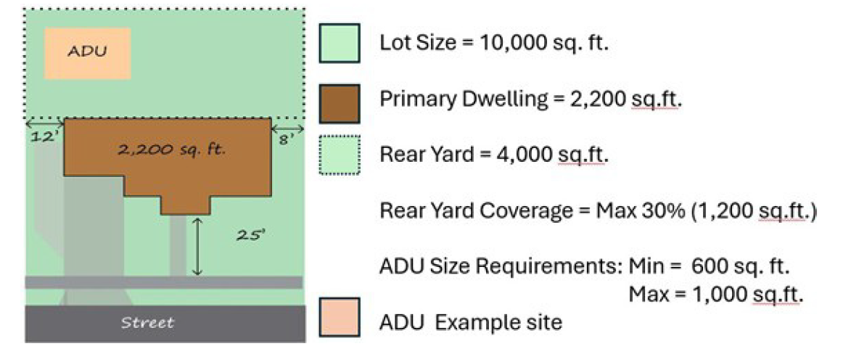

(9) Setbacks and Building Heights:
(a) Height and Size Restrictions: All detached external accessory buildings, including ADUEs shall be constructed according to Table 16-1, except that the height shall in no event exceed the height of the primary dwelling. The City Council may approve a special exception to the height and size restrictions for ADUEs, as provided by Chapter 28 of this title, with consideration given to larger lots than required by the minimum lot size of the applicable residential zone, of the architecture and style of the primary building.

Table 16-1
Setback | Maximum Wall Height | Maximum Building Height
3’ | 8’ | 12’
4’ | 9’ | 13.5’
5’ | 10’ | 15’
6’ | 11’ | 16’
7’ | 12’ | 17’
8’ | 13’ | 18’
9’ | 14.5’ | 19’
10’ | 16’ | 20’

(b) All garages and other accessory buildings located within ten feet (10') of the primary building shall be considered attached and part of the primary building and the setback requirements applicable to the primary building shall apply.
(c) Setback Exception: ADUEs and the required parking for the ADUE can be within 5 feet of the property line when the lot is less than 20,000 square feet.
(d) Note: Accessory buildings located closer than five feet (5') to the property line shall be one hour fire resistant construction or shall be less than two hundred (200) square feet as required by the International Residential Code.
(10) Permits Required:
(a) An accessory building with a maximum height of ten feet (10') and a maximum size of less than two hundred (200) square feet shall not require a building permit, provided all setback requirements for the zoning district in which the accessory building is located are met.
(b) The zoning administrator is authorized to approve a class II use application for an ADUE or ADUI that is not part of the original construction of the single-family dwelling unit to which it is associated, provided all requirements of this section, all other applicable requirements of all land use ordinances, and all other regulations are met.
(c) The zoning administrator is authorized to approve a Class II use application for an ADUE or ADUI that is part of construction associated with a new single-family dwelling, provided all requirements of this section, all other applicable requirements of all land use ordinances, and all other regulations are met.
(d) Legalizing Existing ADUEs and ADUIs: Owners of ADUEs or ADUIs existing on the effective date hereof, and that have not been approved as required herein, shall apply for approval within one hundred eighty (180) days of the effective date hereof.
(e) Noncomplying ADUEs and ADUIs: All owners of ADUEs or ADUIs determined to be noncomplying structures, shall be subject to the provisions for noncomplying structures, as provided herein by Chapter 25 of this Title. There will be no impact fees charged for building an ADUE or ADUI.
(11) Parking: A single-family dwelling with an ADUE or ADUI shall provide at least one (1) additional off-street parking space for the ADUE or ADUI, above the minimum spaces required for a single-family dwelling. ADUE and ADUI parking shall be separate from the required parking of the main dwelling and does not include the main driveway of the primary dwelling. If the ADUE or ADUI is larger than six hundred fifty (650) square feet, a second additional off-street parking space is required.
(a) No parking spaces may be located within the front or side yard setbacks adjacent to a street, except within an approved driveway. No parking of trailer, recreational vehicle, or trailers shall be allowed by the ADUE or ADUI tenant.
Example of ADUE or ADUI Lot Parking:
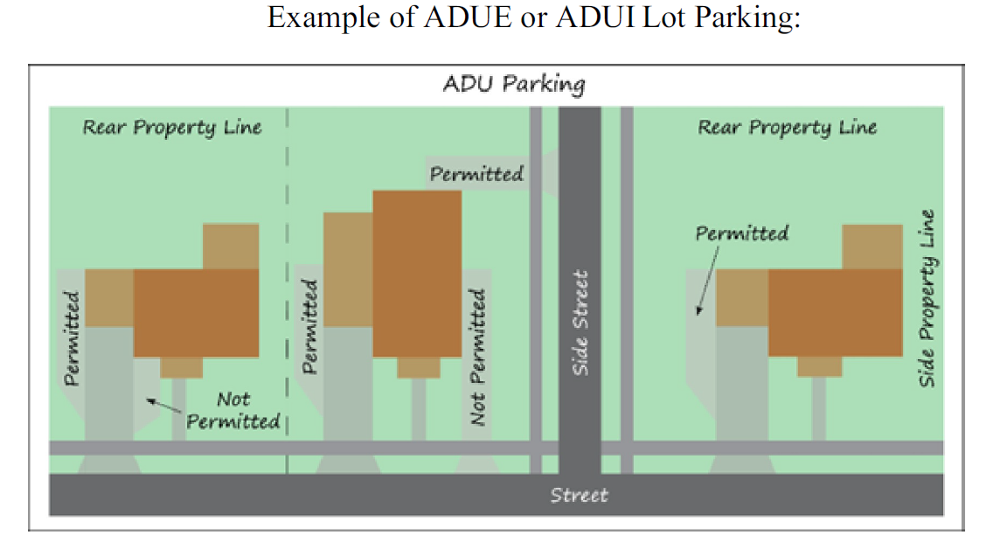

(12) Address: The principal dwelling unit and the ADUE or ADUI shall have the same address number but shall refer to the accessory dwelling unit as Unit B or Unit C if there is both an ADUE or ADUI. Addresses must be located in a visible location on the street front portion of the home.
(13) Not Intended For Sale: No ADUE or ADUI shall be sold or conveyed separate from the primary dwelling unit and shall only be rented.
(14) Home Occupation Business: Home occupation businesses in an ADUE or ADUI shall be restricted to use that creates no customer traffic. No home occupation business shall be established within an ADUE or ADUI without the express written permission of the property owner and pertinent licensing.
(15) Manufactured Dwelling Units: An ADUE may be a manufactured dwelling unit of any type (including modular home, Park model, tiny home, kit home, box home, etc.), so long as the structure is a dwelling unit that is permanently connected to and approved for all required utilities and attached to a site-built permanent foundation that meets the building code. All running gear, tongues, axles, and wheels must be removed at the time of installation.

The foundation, electrical and plumbing portions of the installation process for any offsite manufactured structure must be inspected by the city and found to be in compliance with all applicable building codes. The remaining portions of
the offsite manufactured structure must be subject to a HUD label attached to the exterior of the home certifying the home was manufactured to HUD standards or otherwise be certified in writing by the manufacturer to comply with all applicable building codes based on qualified manufacturer inspections or be inspected by the city and found to be in compliance with all applicable building codes.

(16) Design Standards: An ADUE shall incorporate at least one of the exterior materials used in the principal dwelling for twenty percent (20%) of all facades of the structure. The ADUE rook must match the style and pitch of the principal dwelling, except if the principle dwelling has a pitched rook, the roof of an ADUE that is a tiny home or kit home may be a pitched, flat or slightly pitched shed roof . The ADUE shall maintain the same color of the primary dwelling for at least fifty percent (50%) of all facades and comply with Ivins City Design guidelines set forth in chapter 19 of this title, except to the extent the design guidelines are prohibited by Section 10-20-618 of the Utah Code. Balconies or a second story of an ADUE are prohibited.

16.12.104: LIMITATIONS ON HEIGHT, SIZE AND LOCATION OF GARAGES AND OTHER ACCESSORY BUILDINGS IN RESIDENTIAL ZONES:
In an effort to avoid the appearance of commercial style buildings in residential zones, and to protect the character and stability of residential neighborhoods, the following requirements for garages and other accessory buildings located in residential zones are provided:
(1) Maximum Garage Height:
(a) Detached garage height shall not exceed the heights shown in Table 16-1.
(b) No attached garage shall be higher than the primary building.
(2) Number Of Garages: A maximum of one attached and one detached garage may be allowed on each lot in association with a primary residential dwelling unit. All other structures shall be considered accessory buildings.
(3) Maximum Accessory Building Height: No accessory building, including agricultural use accessory buildings, shall be higher than fifteen feet (15'), measured from average finish grade, unless a higher finished grade is required by the City for proper drainage in which case it will be measured from the finished grade.
(4) Size, Location, And Construction Of Attached And Detached Garages And Other Accessory Buildings In Residential Zones:
(a) Size Of Attached Garages:
(i) The total square footage of any attached garage shall not be greater than fifty percent (50%) of the square footage of the footprint of the primary structure excluding the attached garage on lots less than one-half (0.5) acre, however, that percentage may increase up to sixty percent (60%) provided the garage frontage is less than fifty-five percent (55%) of the total frontage;
(ii) Sixty percent (60%) on lots between one-half (0.5) acre and one acre; and
(iii) Seventy percent (70%) on lots one acre or larger.
(b) The total square footage of any detached garage or other accessory building including agricultural use accessory buildings shall not be greater than fifty percent (50%) of the footprint of the primary structure including the attached garage on lots less than one-half (1/2) acre, sixty percent (60%) on lots one-half (1/2) acre to less than one acre, and seventy percent (70%) on lots one acre or larger. Note: Habitable space located in the attic areas of detached garages shall be included in the total square footage.
(c) Agricultural use accessory buildings constructed prior to the primary building as allowed in the agriculture (A) zone and residential agriculture (RA) zone shall be a maximum of two thousand five hundred (2,500) total square footage and shall be constructed of materials and colors that blend with the natural environment.
(d) Agricultural use accessory buildings larger than two thousand five hundred (2,500) square feet shall require a Class III conditional use permit.
(e) The cumulative total square footage of all attached garages, detached garages and all other accessory buildings, including agricultural use accessory buildings, shall not be greater than twenty five percent (25%) behind the rear wall line of the primary structure.
(f) All garages and other accessory buildings located within ten feet (10') of the primary building shall be considered attached and part of the primary building and the setback requirements applicable to the primary building shall apply.
(g) No detached garage or other accessory buildings shall be located in any required front yard.
Exhibit B
DWELLING UNIT, MANUFACTURED:
(1) A transportable factory built housing unit constructed on or after June 15, 1976, according to the federal home construction and safety standards act of 1974 (HUD code)designed to be used as a dwelling unit with a permanent foundation and connected to the required utilities, including plumbing, heating, air conditioning and electrical systems.
(2) To meet the requirements of this title and state laws, when erected on the site, the manufactured dwelling unit must have exterior and roofing materials acceptable to the building code, as adopted by Ivins City, and be located on a permanent foundation, in accordance with plans providing for vertical loads, uplift and lateral forces, and frost protection in compliance with the building code. All appendages, including carports, garages, storage buildings, additions or alterations, must be built in compliance with the building code. The manufactured dwelling unit must be connected to the required utilities, including plumbing, heating, air conditioning and electrical systems. All manufactured dwelling units constructed on or after June 15, 1976, shall be identifiable by the manufacturer's data plate bearing the date the unit was manufactured and a HUD label attached to the exterior of the home certifying the home was manufactured to HUD standards or otherwise be certified in writing by the manufacturer to comply with all applicable building codes based on qualified manufacturer inspections or be inspected by the city and found to be in compliance with all applicable building codes. A manufactured dwelling unit shall be identified as real property on the property assessment rolls of Washington County.

